(a),

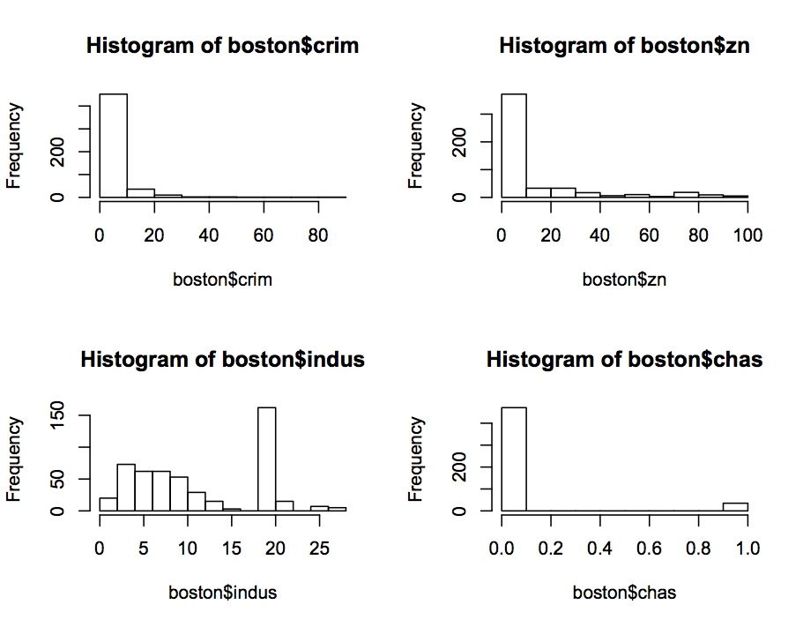

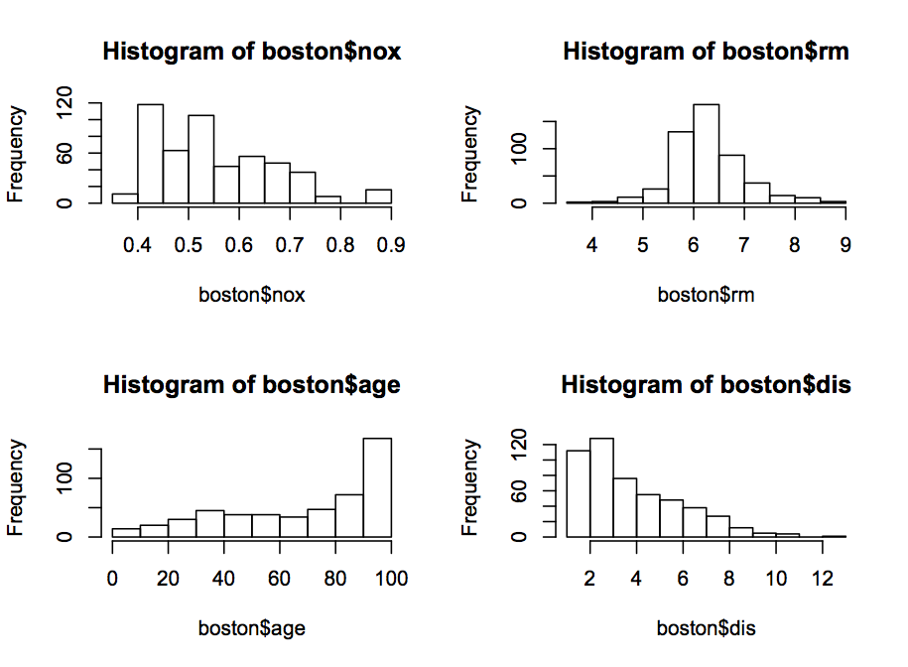

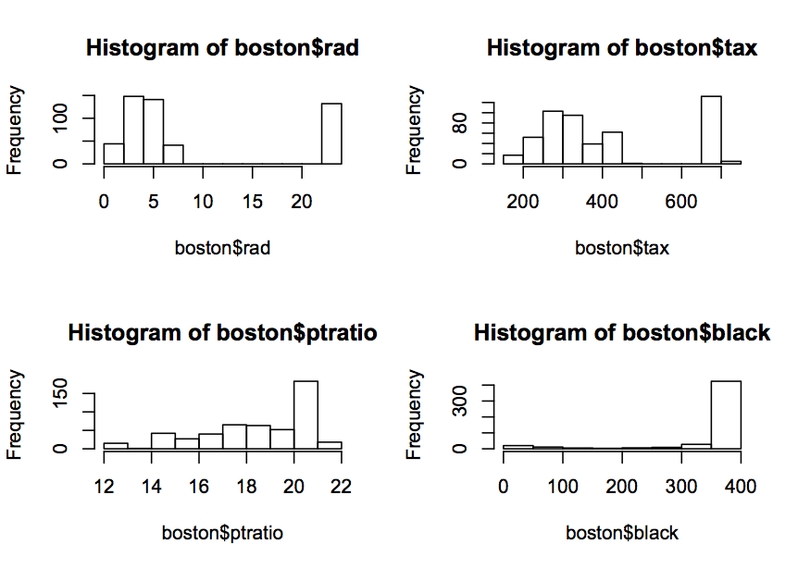

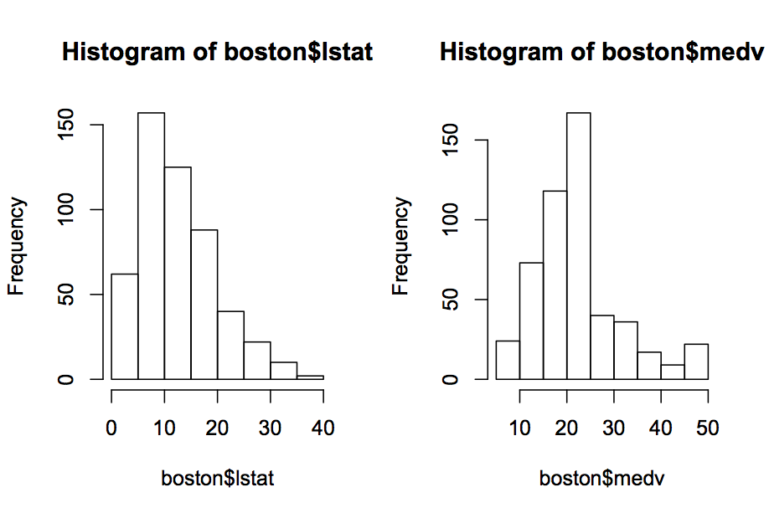

I split the variables’ range to the different parts and label these parts different titles.

CRIM: The split points are 0.006, 0.083, 1.73, 10.76 and 89.

The labels are "Low-crim", "Middle-crim" and "High-crim" and "Super- crim".

ZN: The split points are -0.1, 12.5, 28, 80 and 101.

The labels are "no-lot", "low-lot", "middle-lot", and "high-lot".

Indus: The split points are 0.45, 5.19, 18.1, 19.58 and 28.

The labels are "Low-indus", "Middle-indus", "High-indus" and "Super-indus".

CHAS: The labels are "off-river" for 0 and "near-river" for 1.

NOX: The split points are 0.3, 0.449, 0.605, 0.713 and 0.9.

The labels are "Low-nox", "Middle-nox", "High-nox" and "Super-noxs".

RM: The split points are 3, 5, 7 and 9.

The labels are "small-house", "Middle-house" and "big-house".

AGE: The split points are 2, 25, 45, 65 and 100.

The labels are "Young", "Middle-aged", "Senior" and "Elderly".

DIS: The split points are 1, 4, 7, 10 and 13.

The labels are "Low-dis", "Middle-dis", "High-dis" and "Super-dis" .

RAD: The split points are 0.5, 3, 5 , 8 and 24.

The labels are "Low-index", "Middle-index", "High-index" and "Super-index".

TAX: The split points are 180, 300, 500 and 720.

The labels are "Low-tax", "Middle-tax" and "High-tax".

PTRATIO: The split points are 12, 17, 20 and 23.

The labels are "Low-ptratio", "Middle-ptratio" and "High-ptratio".

B: The split points are 0, 100, 300 and 400.

The labels are "Low-black", "Middle-black" and "High-black".

LSTAT: The split points are 1, 10, 20 and 40.

The labels are "Low-lstat", "Middle-lstat" and "High-lstat".

MEDV: The split points are 0, 15, 25, 40 and 55.

The labels are "Low-value", "Middle-value", "High-value" and "super-value".

(b),

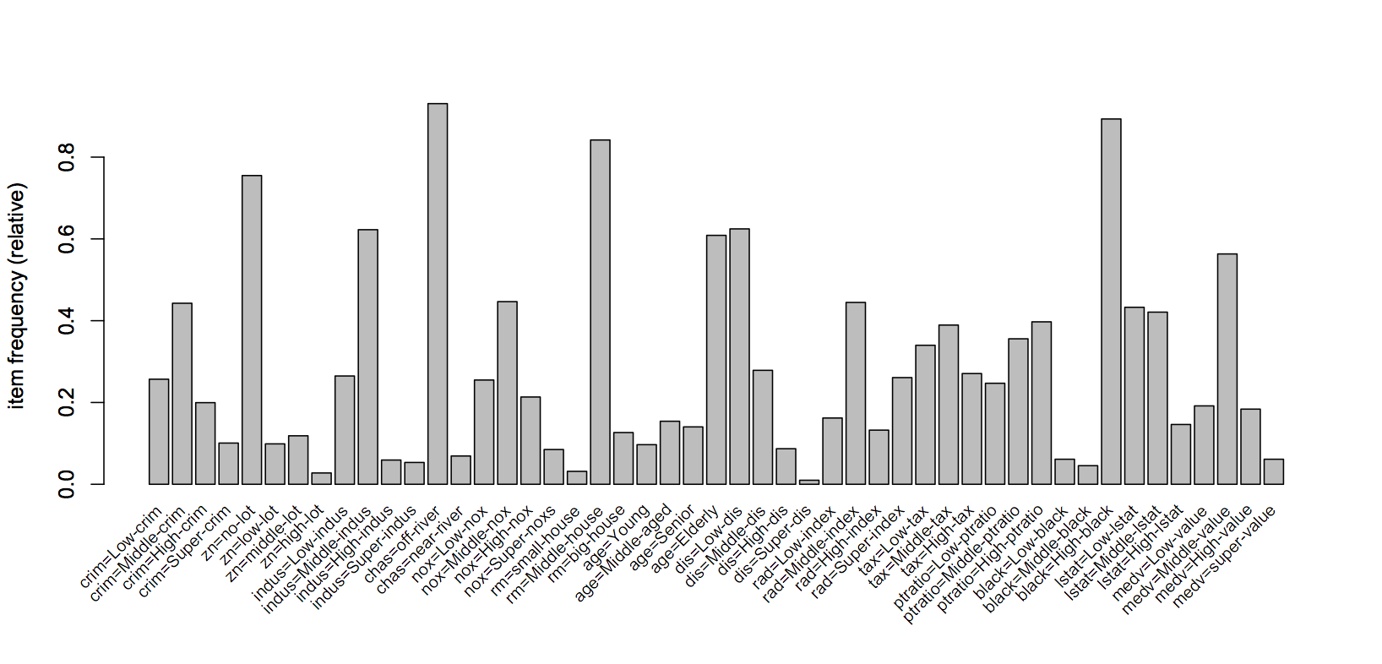

Support = 0.02, confidence = 0.8

(c),

I specify the “dis=Low-dis “ on the left side and “crim=Low-crim” on the right side. The fellow results are the first five rules that meet the requirement.

lhs rhs support confidence lift

1 {indus=Low-indus,

nox=Middle-nox,

dis=Low-dis,

ptratio=Middle-ptratio,

lstat=Low-lstat} => {crim=Low-crim} 0.02173913 0.8461538 3.293491

2 {indus=Low-indus,

nox=Middle-nox,

dis=Low-dis,

tax=Low-tax,

ptratio=Middle-ptratio,

lstat=Low-lstat} => {crim=Low-crim} 0.02173913 0.8461538 3.293491

3 {indus=Low-indus,

nox=Middle-nox,

dis=Low-dis,

ptratio=Middle-ptratio,

black=High-black,

lstat=Low-lstat} => {crim=Low-crim} 0.02173913 0.8461538 3.293491

4 {indus=Low-indus,

chas=off-river,

nox=Middle-nox,

dis=Low-dis,

ptratio=Middle-ptratio,

lstat=Low-lstat} => {crim=Low-crim} 0.02173913 0.8461538 3.293491

5 {indus=Low-indus,

nox=Middle-nox,

dis=Low-dis,

tax=Low-tax,

ptratio=Middle-ptratio,

black=High-black,

lstat=Low-lstat} => {crim=Low-crim} 0.02173913 0.8461538 3.293491

(d),

I specify the “ptratio=Low-ptratio “ on the right side. The fellow results are the first five rules that meet the requirement.

lhs rhs support confidence lift

1 {indus=High-indus} => {ptratio=Low-ptratio} 0.05928854 1 4.048

2 {indus=High-indus,

nox=Super-noxs} => {ptratio=Low-ptratio} 0.03162055 1 4.048

3 {crim=High-crim,

indus=High-indus} => {ptratio=Low-ptratio} 0.03754941 1 4.048

4 {indus=High-indus,

tax=Middle-tax} => {ptratio=Low-ptratio} 0.05928854 1 4.048

5 {indus=High-indus,

lstat=Middle-lstat} => {ptratio=Low-ptratio} 0.02766798 1 4.048